**VPC FLOWLOGS**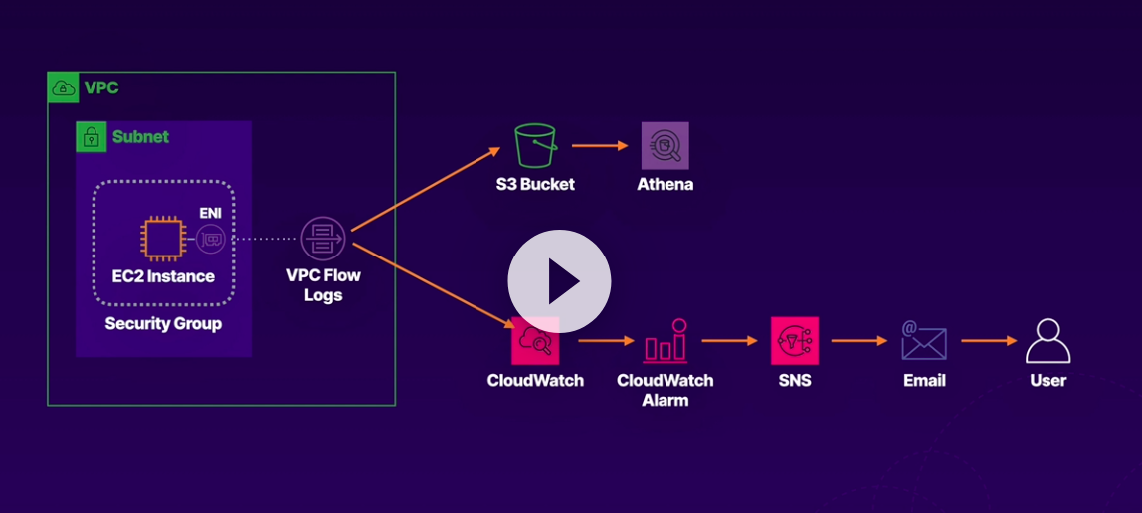

### **Create CloudWatch Log Group and VPC Flow Logs to CloudWatch and S3**

#### **Create VPC Flow Log to S3**

1. Navigate to ****VPC**** > ****Your VPCs****.
2. Select the A Cloud Guru VPC.
3. At the bottom of the screen, select the Flow logs tab.
4. Click ****Create flow log****, and set the following values:
   1. Filter: ****All****
   2. Maximum aggregation interval: ****1 minute****
   3. Destination: ****Send to an Amazon S3 bucket****
   4. S3 bucket ARN:
      1. Navigate to S3 in a new browser tab.
      2. Select the provided bucket (it should have vpcflowlogsbucket in its name).
      3. Click ****Copy ARN****.
      4. Return to the VPC tab and paste in the value.
         1. This value can also be found on the lab page.
5. Leave the rest as their defaults and click ****Create flow log****.
6. Select the Flow logs tab and verify the flow log shows an Active status.
7. In the S3 browser tab, click to open the bucket.
8. Click the Permissions tab.
9. Scroll down to Bucket policy.
10. Notice the bucket path in the policy includes ****AWSLogs****.

Note: It can take 5–15 minutes before logs appear, so let's move on while we wait for that to happen.

#### **Create CloudWatch Log Group**

1. In a new browser tab, navigate to ****CloudWatch**** > ****Logs**** > ****Log groups****.
2. Click ****Create log group****.
3. In Log group name, enter "VPCFlowLogs".
4. Click ****Create****.

#### **Create VPC Flow Log to CloudWatch**

1. Back in the VPC browser tab, click ****Create flow log****, and set the following values:
   1. Filter: ****All****
   2. Maximum aggregation interval: ****1 minute****
   3. Destination: ****Send to CloudWatch Logs****
   4. Destination log group: ****VPCFlowLogs****
   5. IAM role: Select the role with ****DeliverVPCFlowLogsRole**** in the name.
2. Leave the rest as their defaults and click ****Create flow log****.
3. Under the Flow logs tab, verify the flow log shows an Active status.
4. In the CloudWatch browser tab, click the VPCFlowLogs log group to open it.

Note: It can take 5–15 minutes before logs start to show up, so let's move on while we wait for that to happen